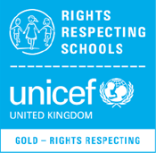
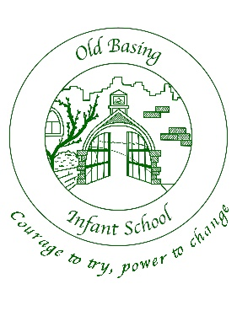
PSHE at Old Basing Infants

 | Autumn 1 | Autumn 2 | Spring 1 | Spring 2 | Summer 1 | Summer 2
Reception | Ready to Shine  Meet your brain | Celebrate | Appreciate | Relate | Engage | MyHappyBody  MyHappyRelationships  MyHappyWorld
Year 1 | Zones of Regulations  Meet your brain | Celebrate  Respect and managing hurtful behaviour | Appreciate  Healthy  Lifestyles | Relate  Families and relationships | Engage  Shared responsibilities | Communities  Ourselves, Growing and changing
Year 2 | Zones of Regulations  Meet your brain | Celebrate  Keeping Safe | Appreciate  Media Literacy and Digital Resilience | Relate  Friendship | Engage  Safe relationships | Ourselves, Growing and changing  Transition

Ready to Shine - resource is a structured 5-week transition programme designed specifically to help children build resilience and confidence as they prepare for new school environments.
Meet the Brain - Understanding how your brain works and how to ensure we look after it so that we can manage our emotions and be at our best. Growth mindset is a key part of this too.
Celebrate - Understanding your unique Character Strengths and learning to celebrate them. This is a fantastic module for building self-esteem
Appreciate – Understanding why gratitude matters and how you can develop gratitude as a habit. Gratitude is key to well-being and resilience and we're all about making it a lifelong strategy!
Relate – Understanding why positive relationships matter and how to build them. We're focussed on the building blocks of good relationships and friendships.
Engage - Understanding how to set meaningful goals that matter and how to stay resilient in times of challenge. This module is all about building self-esteem and resilience too.

Families and Relationships and Safe Relationships the children learn to:
Families: Learn what a family is and who is in their family. Understand that families can be different (e.g. single parents, adoptive families) and that families care for each other. Know who to talk to if something feels up setting.
Friendship: Learn what makes a good friend. Understand that friends can fallout and how to resolve simple disagreements. Know how to ask for help.
Respecting: Learn that everyone is unique, to respect differences and show kindness. Understand that words and actions can hurt others and know to tell an adult if worried

MyHappyBoday, Healthy Lifestyles, Ourselves Growing and Change the children learn to:
Learn that their body belongs to them. Use correct names for body parts (e.g. penis, vulva). Understand private parts, safe/unsafe touch, and trusted adults.
Mental Health and Wellbeing: Recognise and name basic feelings and understand that feelings affect behaviour. Learn simple strategies to manage emotions and who can help.
Keeping Healthy and Well: Learn basic hygiene, sleep routines and sun safety. Know who helps keep them healthy and who to talk to if they are worried about their health. Learn that being active and eating a range of foods helps keep us healthy. Learn that people grow and change as they get older.
Personal safety and First Aid: Learn simple safety rules (road, water, home), how to get help and how to call 999 in an emergency.

MyHappyWorld and Digital literacy and Digital Resilience the children learn to:
Online and Safety: Learn how people use the internet and that not everything online is true. Learn to be kind online. Learn how age restrictions protect wellbeing online and follow basic online rules. Learn how to speak toa trusted adult.
Drug education: Learn that medicines can help but some substances can be harmful. Understand basic safety around substances.
Economic Wellbeing: Learn what money is, where it comes from and how it is used. Begin to understand saving, spending and needs vs wants.
Careers, education, Learning and Working: Learn about different jobs and begin to recognise their own strengths and interests.

